Notes on WebPack
Understand SST vs SPA.
- Understand the ecosystem about dynamic rich websites
  - Websites with menus and buttons,
  - ServerSide Templating (SST)
    - depends on backend server to create an HTML doc and send it to the user
    - Flow of page
    - User visits page → HTTP request to server → new html doc → user clicks a link → new http request to server → new html document
  - Single Page App (SAP)
    - server sends bare bones html doc
    - javascript runs on the users machine to assemble a full webpage
    - Flow of page
      - User visits page → http request sent to server → new html doc → react/angular boots up, shows page → user clicks link → react shows new content
  - Single Page Apps require more JS on the user part to build a page. SPA uses more amount of javascript as opposed to rendering it on the server.

Imagine a file has thousands of codes long in 3 files? How would you refactor it?
Javascript modules – individual files that contain small amounts of code

Problems due to many individual modules:
Picture the following:
index.js ← [(store.js ← api.js) + utils.js ]
1. Sometimes, files will load but content will not be available because some modules haven’t finished loading.
2. Also, loading them over an HTTP connection will decrease performance; it will take a long time.

Webpack fixes the problem with large amounts of individual modules.
What is webpack?
Takes our big collection and merge them into a bundle. It ensures each file is loaded in the correct order.
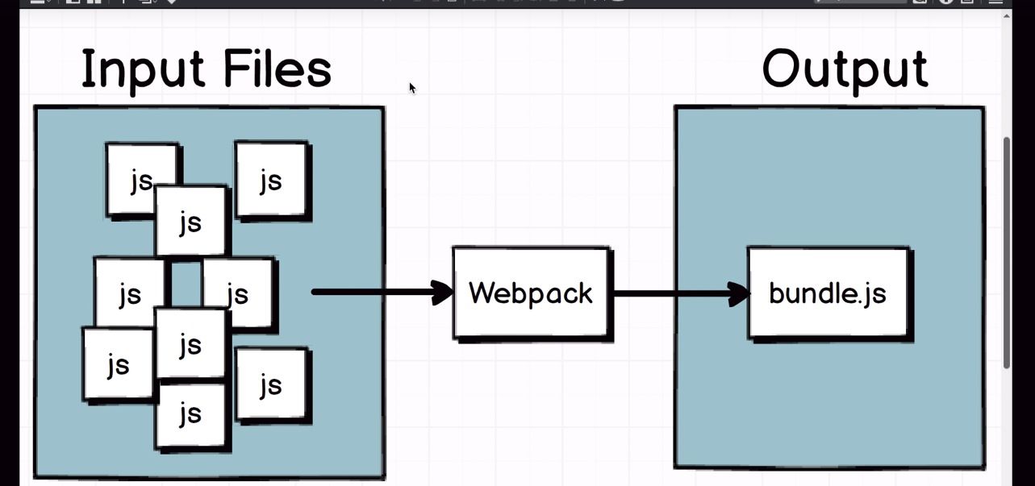
Webpack is an npm dependency.

Different types of module systems
- CommonJS – mainly used in node modules
  - sender file needs module.exports
  - reciever file needs require
  - *reference lab 1 for implementation
- AMD – Asynchronous module definition – used mainly in front end applications
  - sender file needs define
  - reciever file needs require
- ES2015 – ecmascript standard 2015
  - sender file needs export
  - reciever file needs import

Use an entry property – AKA entry point.
Index.js is usually the entry point

Getting started with webpack configuration
- Install webpack
  - npm install --save-dev webpack@2.2.0-rc.0
- Make a file called webpack.config.js in the root directory
/project1
webpack.config.js
- Create an entry point in webpack config file
//webpack.config.js
//const confi = {
entry: ‘./src/index.js’
}
module.exports = config;
- Enter in output property
//webpack.config.js
const path = require(‘path’);
//const confi = {
entry: ‘./src/index.js’,
output: {
path: path.resolve(__dirname, ‘build’) ,
filename: ‘bundle.js’
}
}
module.exports = config;
- Add the following code json
"scripts": {
"build": "webpack"
},
**Note – webpack will run command globally.
Npm run build will run the webpack locally

Why is the bundle file greater than the individual files?
Webpack takes all of our modules, stuffs it into individual functions, stuffs those in that array, then calls individual elements in that array
No magic code is made

Handling Project Assets

What are loaders?
Think of Babel.Used to transpile javascript code from 1 to another. Useful to run javascript code on legacy technologies. These enhance the way webpack is run.
Babel needs 3 modules to start working
- babel-loader : teaches babel how to work with webpack
- babel-core : knows how to take in code, parse it, and generate output files
- babel-preset-env: ruleset for telling babel exactly what pieces of es2015 syntax to loko for and how to turn it into es5 code.

Setting up Babel
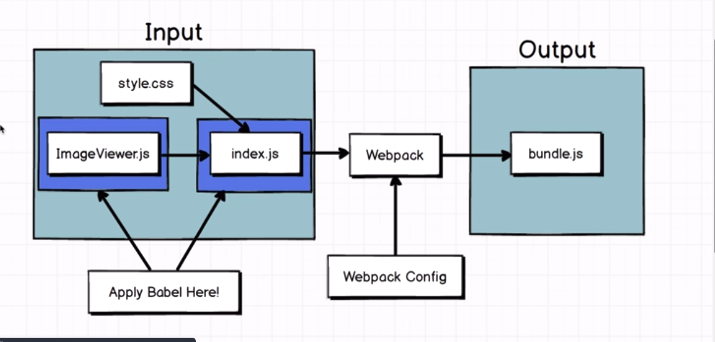
Only apply Babel to files that will need to be transpiled. NO CSS OR HTML files.

- Include this into the following webpack.config file
module:{
rules:[
{
use: 'babel-loader',
test: / \.js$ /,
}
]
}

